1. **Steps for creating RDS Database…..**
2. Goto AWS console select RDS at search bar …
3. Redirected to the RDS interface…their select DATABASES..
4. Selct create database…

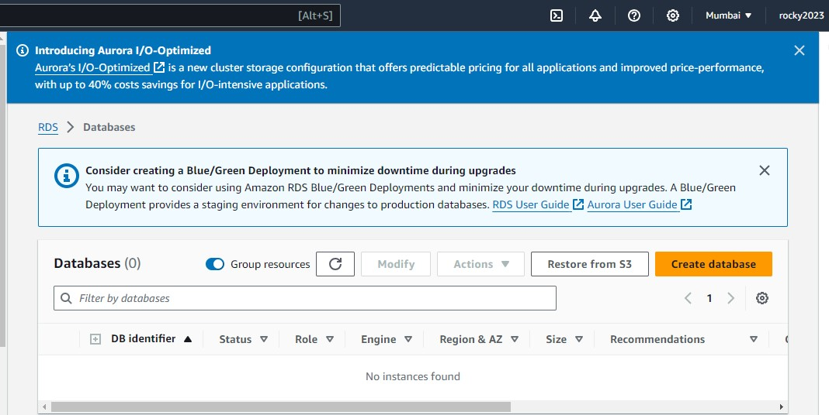

1. **Here choose standard create in this choose database creation method…**

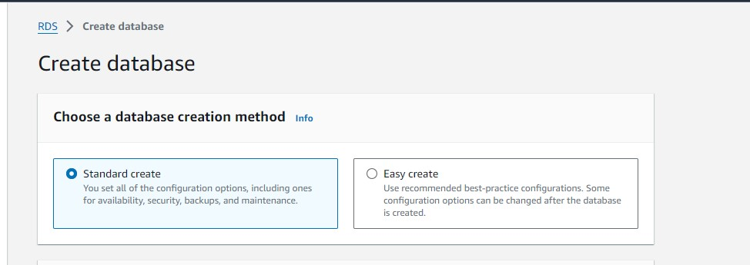

1. **Select ENGINE OPTIONS…Here select MYSQL….**

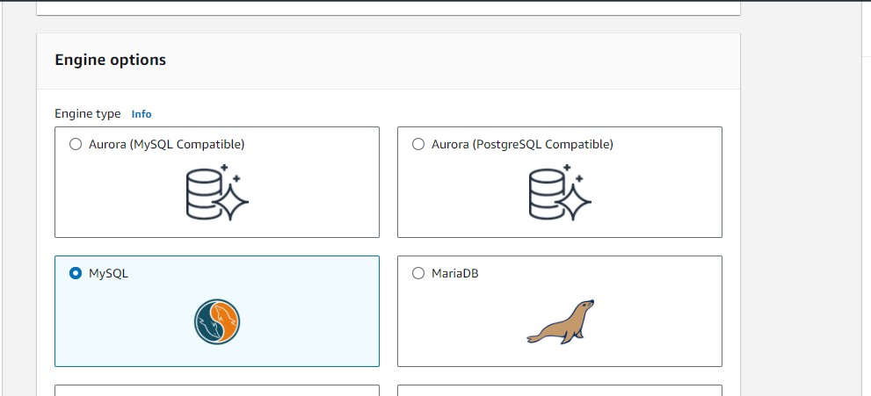

1. **Select the version ..I selected MYSQL 8.0.35**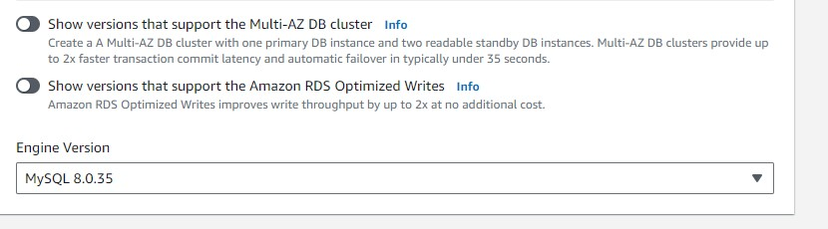
2. **Select the templates and here I selected free tier…**

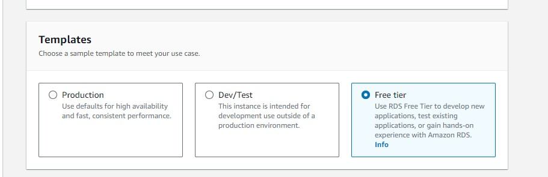

1. **IN settings Give name at DB instance field…**
2. At master username ..laeve as ADMIN ONLY because its default for MYSQL…

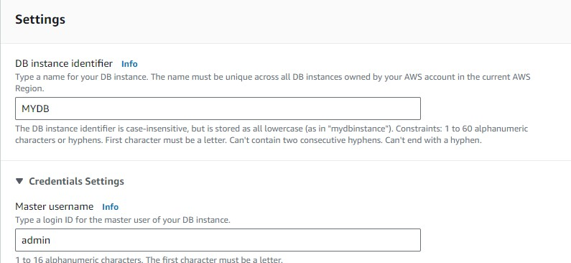

1. **In creadentials management select the option self managed …Add password at required fields**

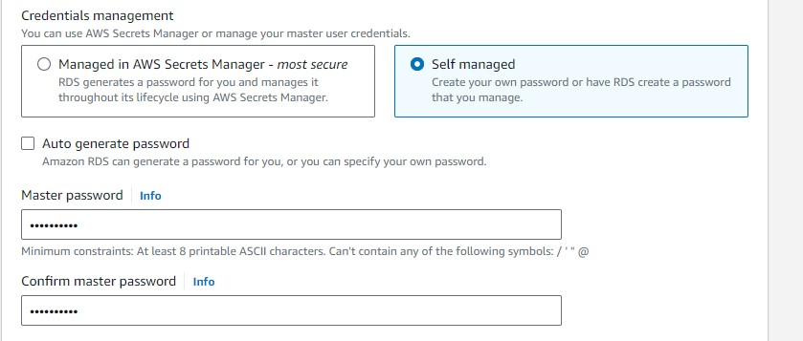

1. **Here select public access …VPC security choose existing..**

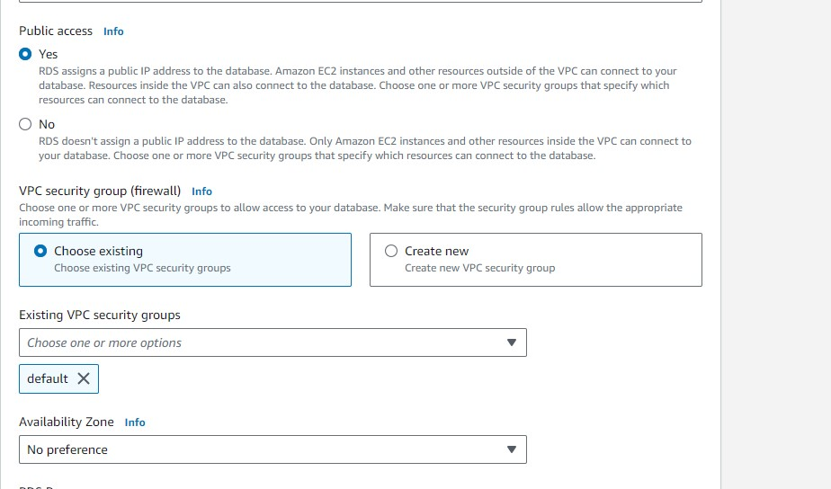

1. **IN Database authentication select password authentication…**

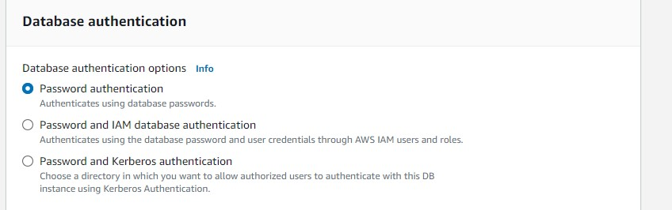

1. **Select create database…**

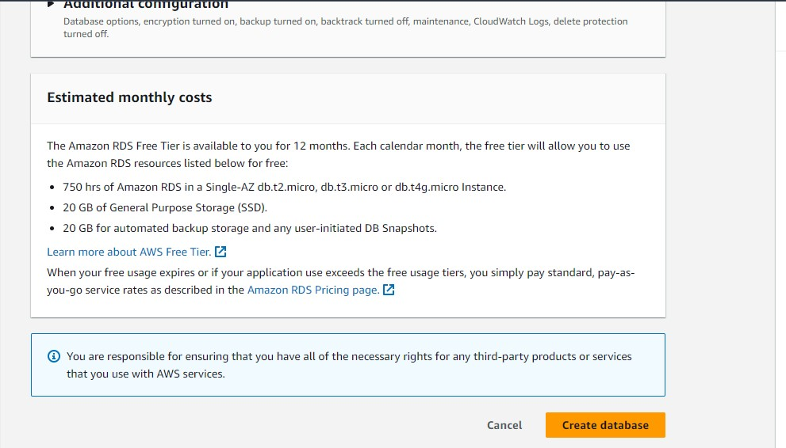

1. **Creating database it will take some time to create…**

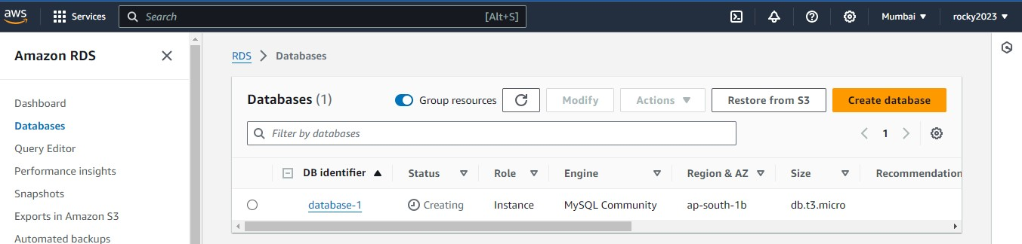

1. **Successfully created database..**

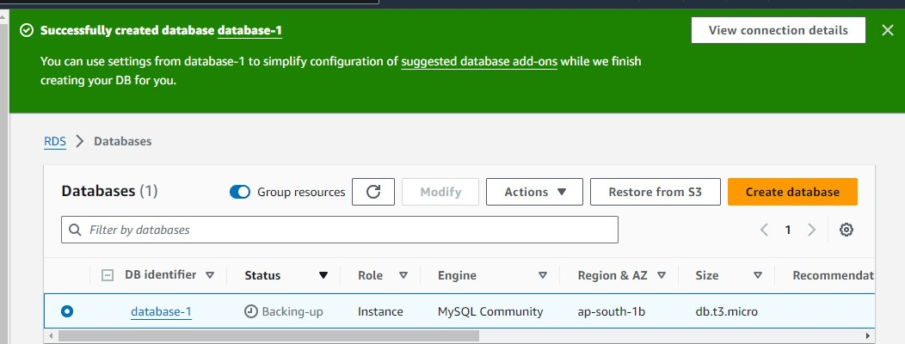

1. **Her edit security group bec to allow traffic to connect ….**

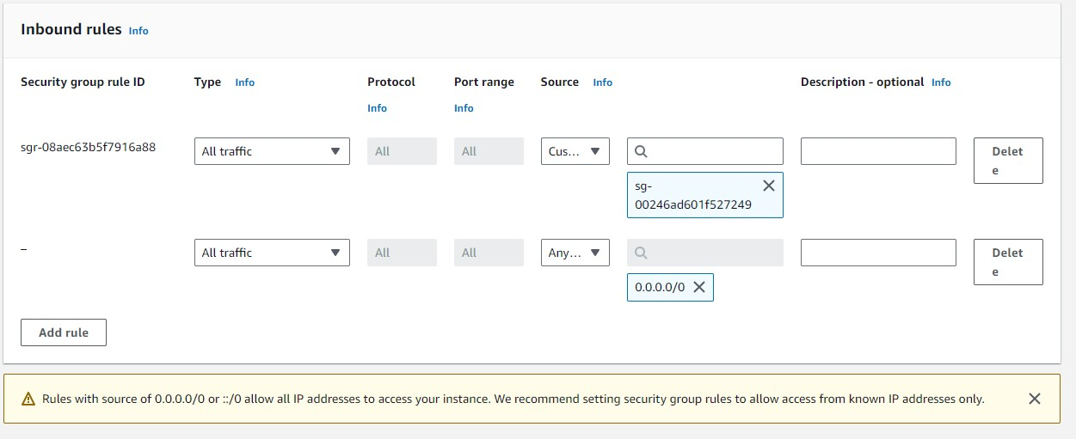

1. **After entering required credentials ..Succesfully made the MySQL connection…**

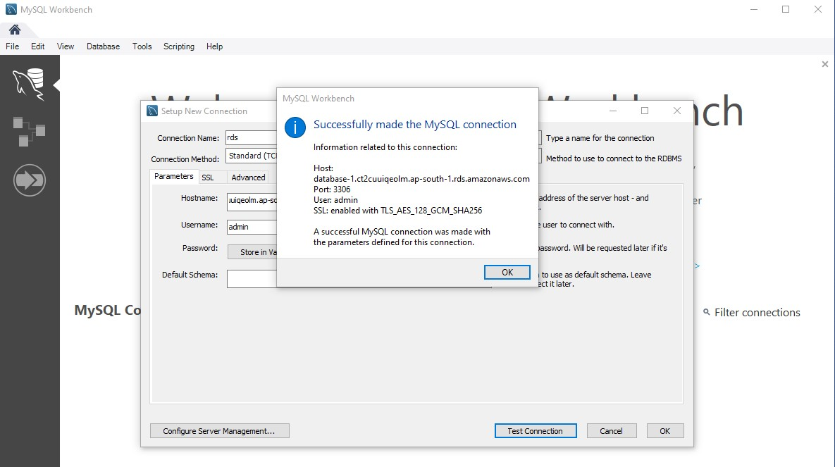

1. **Entered in to the MYSQL WORKBENCH…**

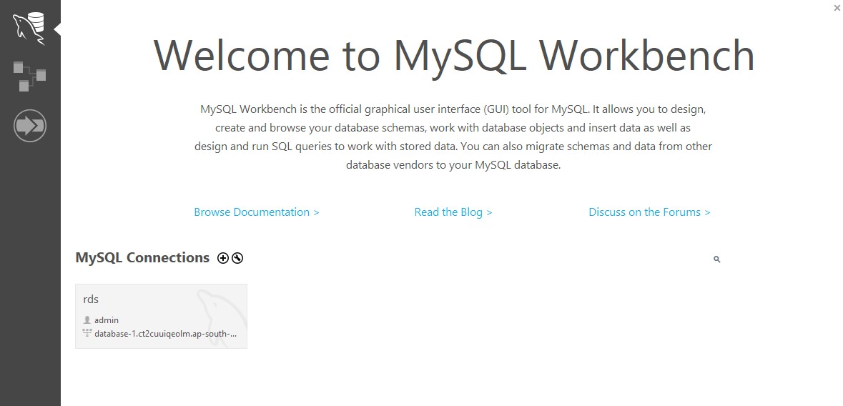

1. Its here MYSQL workbench….. 